User Manual for Hadoop Cluster Sample Application

Abstract:

This document captures the detailed functional specifications for Hadoop Sample Application that perform certain map-reduce transaction on the provisioned cluster.

**Table of Contents**

1. Objective 3

2. Requirement……..……………………………………………………………………………………………………………………..3

3. User Guide 3

1. **OBJECTIVE**

Overall objective of this work is to develop a Web Application which can be deployed on to Hadoop Cluster to perform certain map-reduce transaction on the provisioned cluster.

PURPOSE:

This application can be used to retrieve the **TITLE** of the web page of specific **URLs** .The Application make use of the Hadoop Cluster which distribute the desired Task among the slaves nodes of Cluster and their by Increasing the speed of Computation.

1. **REQUIREMENTS**

* Hadoop Cluster
* Web Server(ex- vFabric TC server)

1. **USER GUIDE**

The sample application can be accessed from the url http://<JobTrackerIP>:8080:/HadoopDemoApp/Login.jsp

**3.1 Login Page**

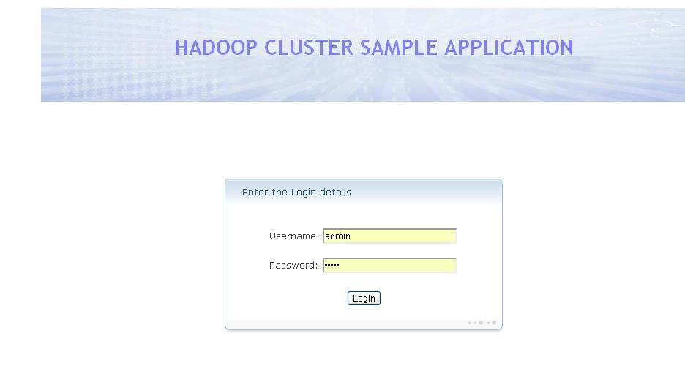

* **Login** is used for the authentication of the user for the Hadoop Sample application. Username/Password: admin/admin
  1. **MAIN PAGE**

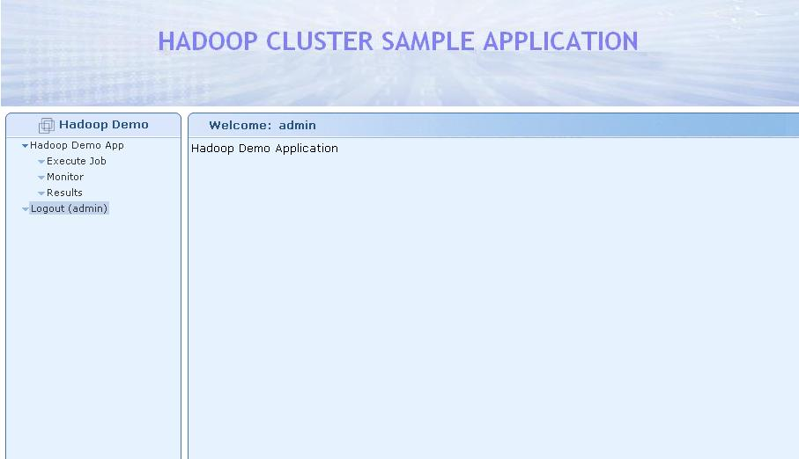

* **Hadoop Demo App** for Navigation Purpose to Execute, Monitor and Result of the Job.
* **Logout** is to Log Out from the Application.

**3.3 Execute Job**

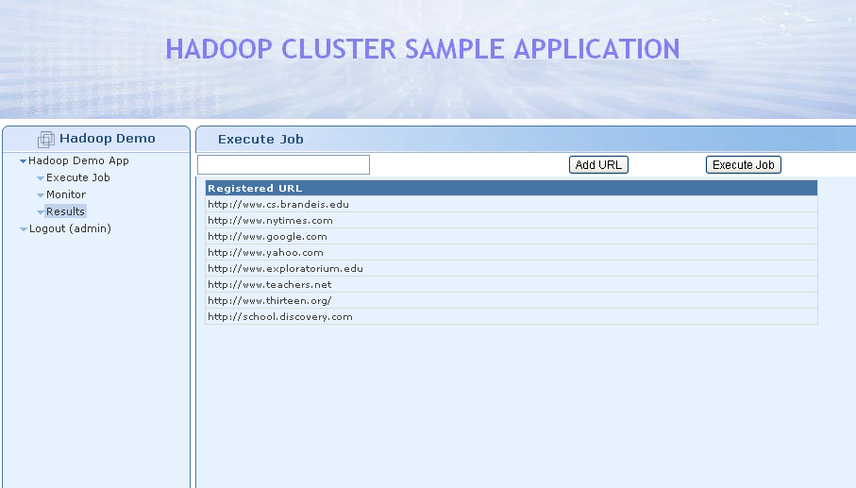

* **Add URL** can be used to add the URLs of which the Title has to be retrieved.
* **Execute Job**  is for executing the Hadoop Job.
  1. **Monitor**

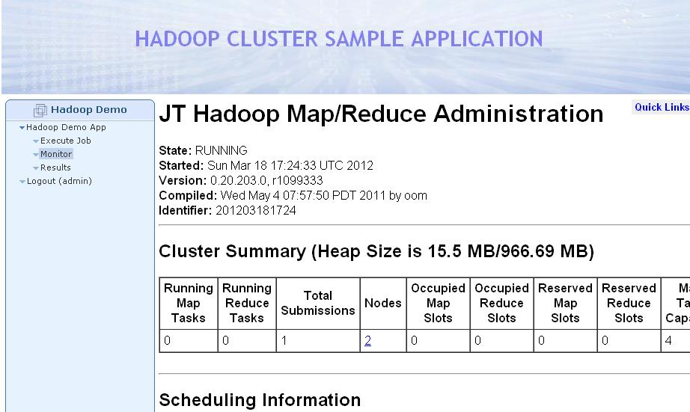

* **Monitor** is for monitoring the execution of Hadoop Job.
  1. **Result**

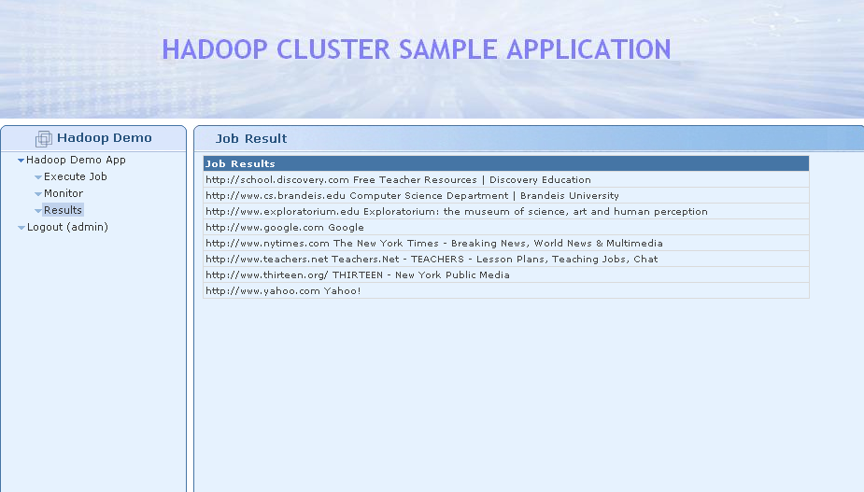

* **Result**  is to display the results of the Hadoop Job submitted to the Application.